CONFERENCE REGISTRATION FORM
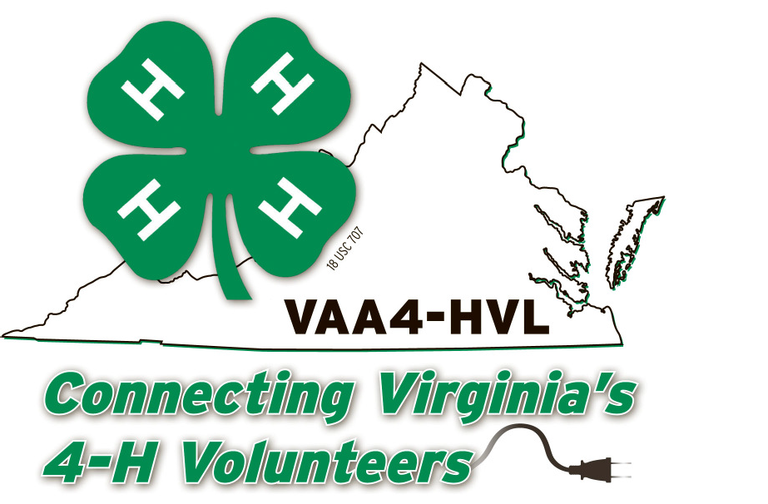
Virginia Association of Adult 4-H Volunteer Leaders
2019 Spring Conference
March 30-31, 2019
“Celebrate the Past, Embrace the Future”

Williamsburg Woodlands Hotel & Suites
105 Visitor Center Drive, Williamsburg, VA 23185
For Reservations Call (800) 261-9530 Room Rates: $108 per night plus tax
Ask for reservations for the “VA Assoc of Adult 4-H Volunteer Leaders”
February 27, 2019 – deadline for hotel room at Conference discounted rate

Conference Registration form must be postmarked by March 4, 2019 to avoid the $15 late fee.

Name: Phone: (with area code)
Address:
City/State: Zip:
County/City: ___________________ District: _________ E-Mail: _______________________________

Participant Status:
4-H Volunteer Extension Agent District/State Staff
Unit Representative Program Assistant VA Adult 4-H Volunteer Leader’s Association
Other: _____________________________________________________

Check here if you do not wish your name, address, phone number and email address placed in the conference registration list, which will be given to each attendee at registration.
Full Conference Registration for each registered participant = $70.00. Includes all workshops and two meals (Saturday buffet lunch and plated dinner); does NOT include lodging. All breakfast meals are included with the hotel room.

Breakfast included with lodging.

Conference Fees:
Full Registration= $70 - with this registration please pick one plated dinner: _________________
_____ Braised Beef Steak ______ Mustard Glazed Smithfield Pork Loin
Caramelized Mushroom & onion gravy Dried Cherry cornbread custard, Roasted Vegetables
Garlic Mashed Potatoes, Green Beans Carrots with Pan Gravy
Saturday night banquet only = $35.00 (4-H Attire for everyone! Can be camp shirts for family members)
LATE FEE (postmarked after 3/4/19 on all or part of conference checked above) = $15.00
No refunds will be made after registration deadline!

Spouses or children meal fee $55.00 (Lunch and Dinner). Does not include workshops. Spouses and
children wishing to attend workshops must pay the full registration fee of $70 and submit a separate form.
List meal only spouse/children names here with dinner choice: ___________________________________________

TOTAL $

Make Check or Money Order payable to: “Southeast District 4-H Volunteers”
Mail this form with your payment to: Mary Bowman, Conference Registrar, VCE-Westmoreland, P.O. Box 8, Montross, VA 22520
There is a $50.00 fee for returned checks.
A duplicate registration form must be sent to Mary Bowman, Conference Registrar if the registration fee is being paid by HokieMart, agency account, or VTF account transfer.

Check if you have special dietary requirements or other accommodations needed. Please list:
__________________________________________________________________________________________
__________________________________________________________________________________________

Virginia Cooperative Extension programs and employment are open to all, regardless of age, color, disability, gender, gender identity, gender expression, national origin, political affiliation, race, religion, sexual orientation, genetic information, veteran status, or any other basis protected by law. An equal opportunity/affirmative action employer. Issued in furtherance of Cooperative Extension work, Virginia Polytechnic Institute and State University, Virginia State University, and the U.S. Department of Agriculture cooperating. Edwin J. Jones, Director, Virginia Cooperative Extension, Virginia Tech, Blacksburg; M. Ray McKinnie, Administrator, 1890 Extension Program, Virginia State University, Petersburg.

If you are a person with a disability and desire any assistive devices, services or other accommodations to participate in this activity, please contact Tara Brent at (804) 580-5694 during business hours of 9 a.m. and 5 p.m. to discuss accommodations at least five days prior to the event. TDD number is (800) 828-1120.
We will be holding a silent and live auction during the conference. Donations of items from each district are greatly appreciated for these events! Proceeds help support our Association.

For more information, including scholarship applications, visit:
https://ext.vt.edu/4h-youth/volunteer-leaders.html.
Workshop descriptions and full schedule will be posted by February 15, 2019.

