Senior Hereford Heifer Questions

Rank these heifers as they would be selected as future donors in a reputable Hereford operation located in the Southeast. This firm has a rich history of producing show cattle that are competitive at the national level; but, the true measure of achievement is generating females that perform in the cow herd. A handful of bulls are marketed to other purebred breeders each year. Feed resources are abundant, however practical females should be able to calve unassisted. 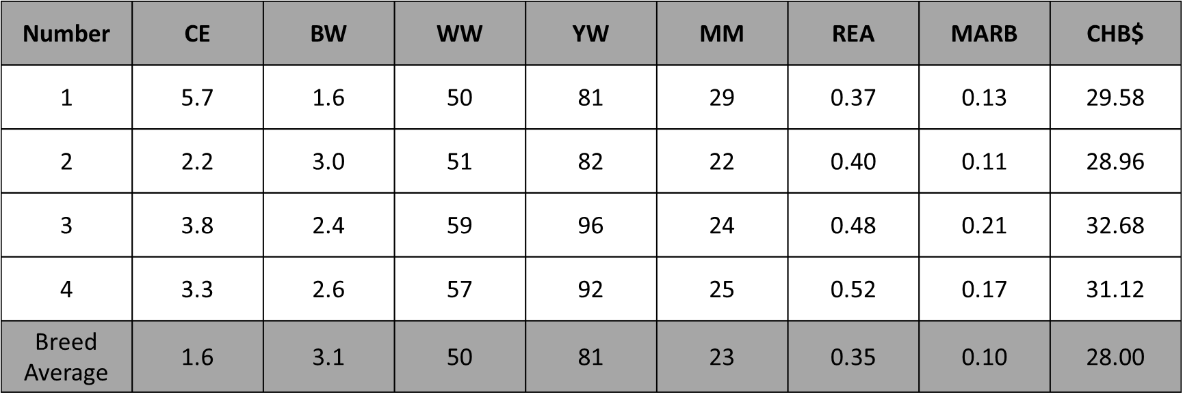

1-2-3-4 | A
1-2-4-3 | B
1-3-2-4 | C
1-3-4-2 | D
1-4-2-3 | E
1-4-3-2 | F
2-1-3-4 | G
2-1-4-3 | H
2-3-1-4 | I
2-3-4-1 | J
2-4-1-3 | K
2-4-3-1 | L
3-1-2-4 | M
3-1-4-2 | N
3-2-1-4 | O
3-2-4-1 | P
3-4-1-2 | Q
3-4-2-1 | R
4-1-2-3 | S
4-1-3-2 | T
4-2-1-3 | U
4-2-3-1 | V
4-3-1-2 | W
4-3-2-1 | X

Mark your class placing on the grid and answer the
following questions.

___ 1. Of the high indexing heifers, who is bold shouldered?

___ 2. Which heifer charts the least maternal?

___ 3. Between 1&2, who has more muscle?

___ 4. Which heifer ties her neck the lowest into her shoulder?

___ 5. Which heifer would be expected to generate the most terminally focused bull progeny?

