CMS Unit Website Quick Reference Guide

Contents
Login: 2
Structure: 2
My Sites: 2
My Assets: 4
Page Templates: 8
Components: 8
Add an Image to your page: 9
Link a Document onto the page: 11
Publish: 13
Breadcrumbs: 13
Social Media: 14

Login:

https://author.ensemble.vt.edu

You will be taken to a login page where you will need to enter your PID and Password

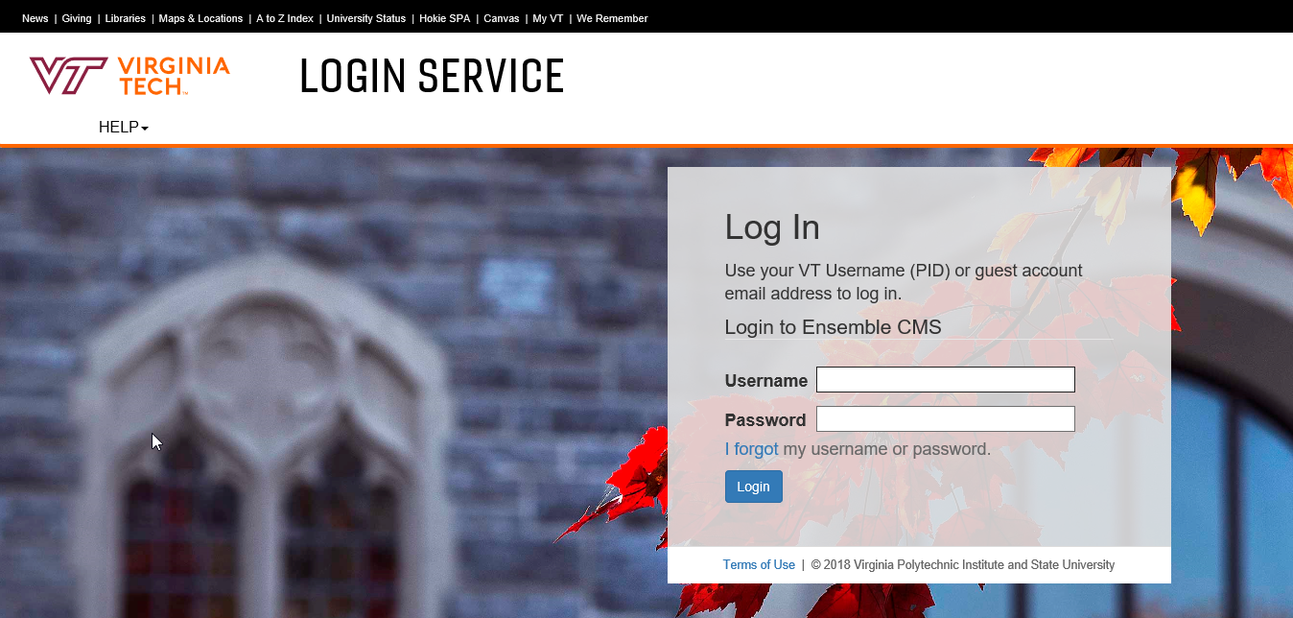

You will then need to complete your 2-factor login
Once you have those steps completed you will then be taken directly into your “My Sites” Tab

Structure:

My Sites:
When you first login you will see the tiled screen for My Sites, My Assets, My Tags, All Sites, and All Assets
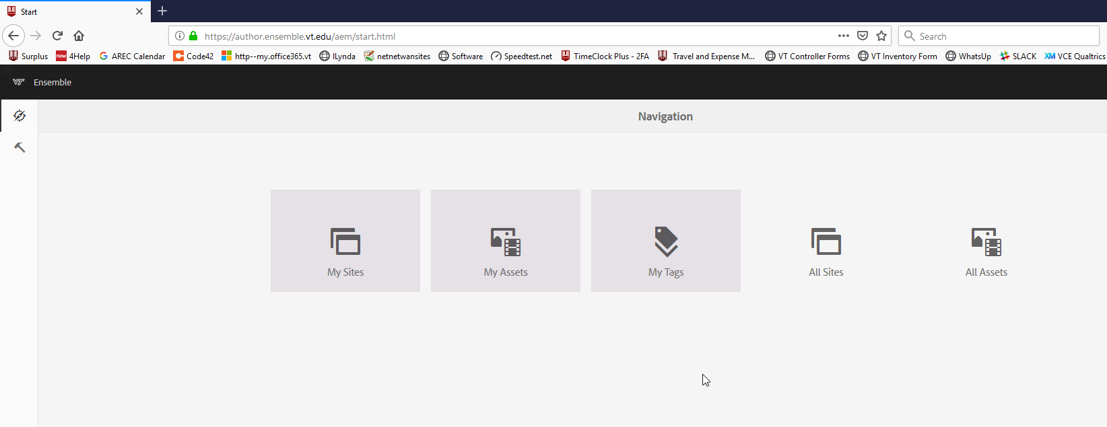
The first site you will see is your website holder. It will hold your settings for your website. There is nothing you will need to change at this level.
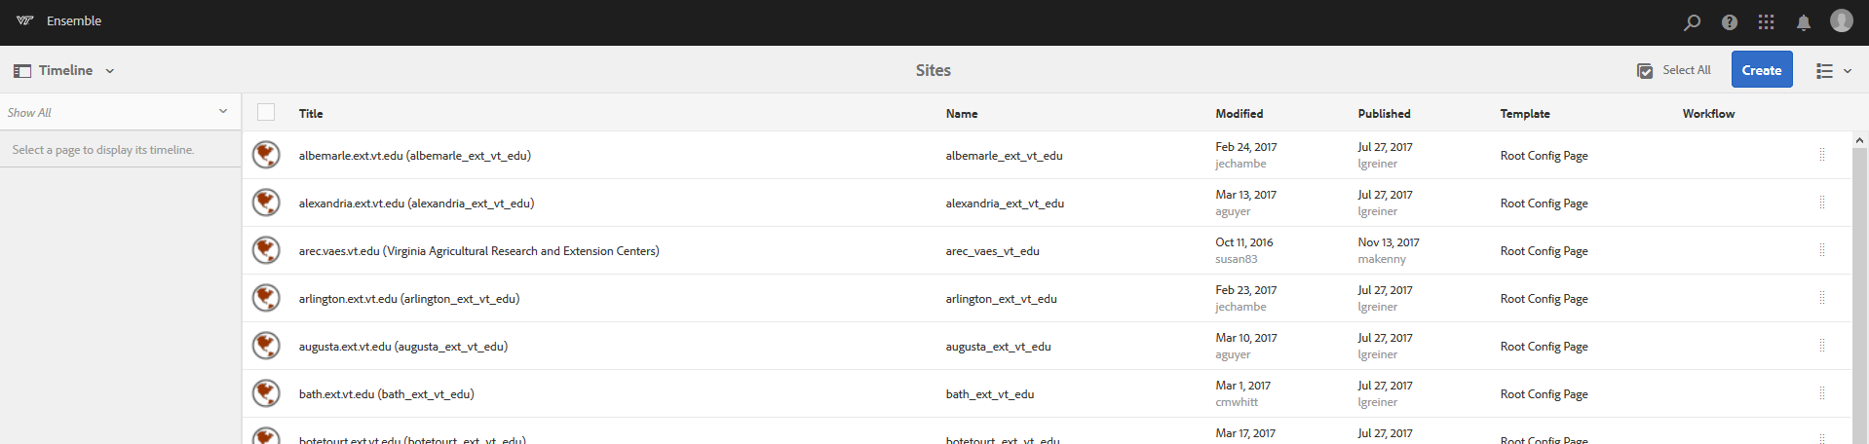

The next level is called your “EN” page. This page controls your inherited sidebar and your footer. The only reason to go into this page if you move offices and you need to change the address or you need to add a Social media link.
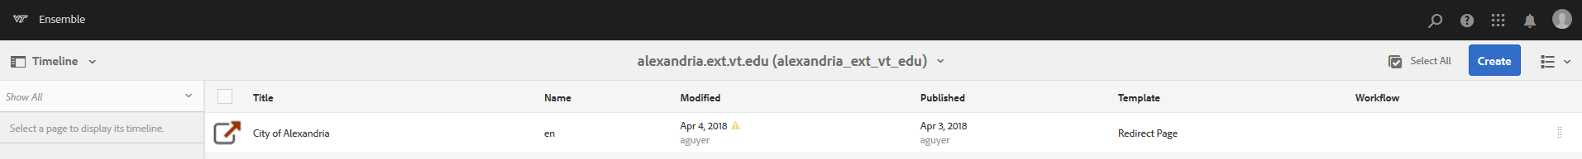
The next level is your pages. Your county name is your “Home” or Index Page. Then your Local Programs, Staff, Get Involved, Calendar, Staff, Contact Us, VCE Home.
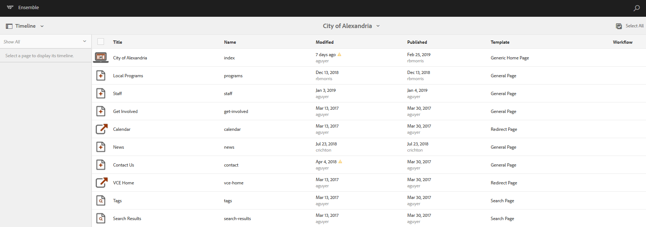

- Index or Home page
  - This is the main page on your website
  - On this page, you will want to highlight who you are and what is going on. This page is just supposed to be a snapshot, if they want to know more you can redirect them to your local programs page.
- Local Programs
  - This page is to provide information on the Programs you offer and support in your office
- Staff
  - This is to provide information to the community on your contact information.
- Get Involved
  - This page is to let your community know how they can get involved
- Calendar
  - This page is to display the upcoming events that you are hosting
- News
  - This page is going to display VT news and updates
- Contact Us
  - This page is going to share your contact information from your office numbers to your office location. It will also contain directions to your office and a map.
- VCE Home
  - This will redirect them back to the VCE Homepage
- Search Results and Tags
  - These two you will not need to make any changes to. They are just placeholders. Your website already has a search but you can always use the components search to specialize one.

My Assets:
You are going to want to select “My Assets” and not “All Assets”. My Assets will just give you your office assets will give you everything.

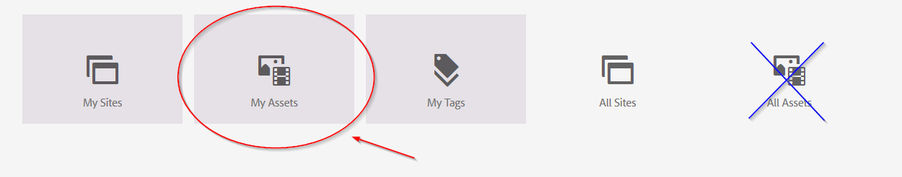

In your assets folder, you should have a folder with Images, and Files. We tried to set up everyone with the same setup so it would be easy to keep things organized.

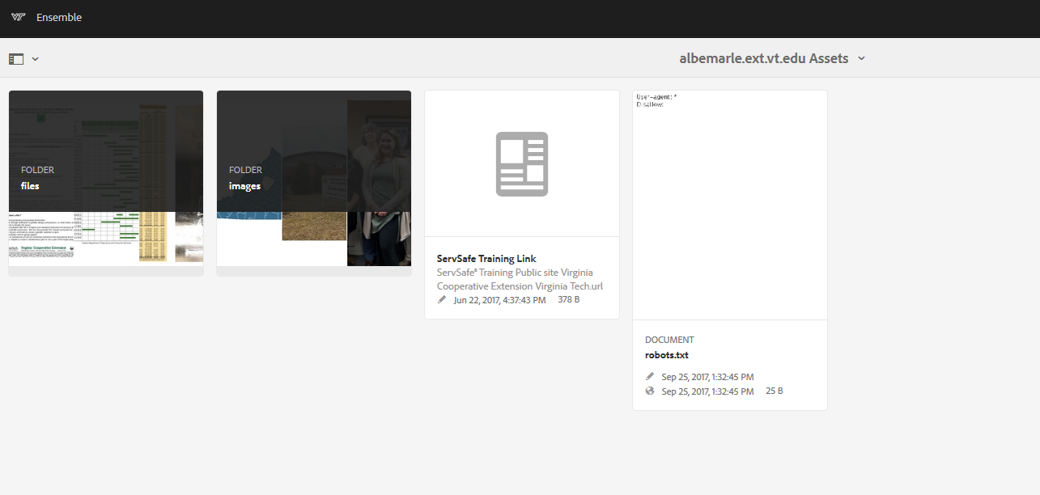

To upload make sure you are in the folder where you want the file to go then you can select “Create” and then “Files”. It will give you a browser window that will allow you to choose the location of your file.
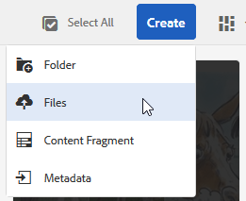
**Please note that your filename cannot have any spaces in the title or it will not work. The most acceptable formats are PDF and JPG.

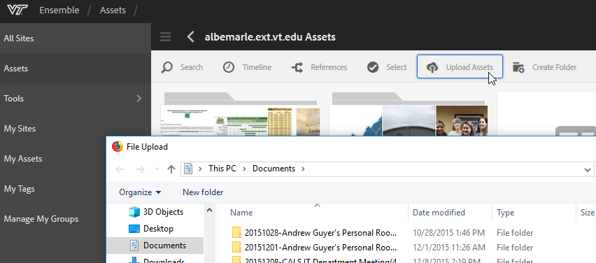

Sometimes after you upload a file you see “Required Metadata Missing” tag at the top of a picture or a file. That is telling you that you are missing a title and alternate title in your properties.

To resolve this notification you will select the “I” on the item (Please note the new icons have changed location)
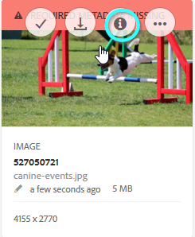

This will take you to the edit step.
if you do not see the “I”, up in the right-hand corner you will need to change your view from to one of the following views
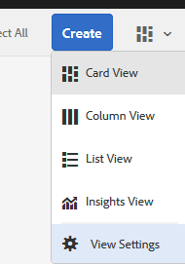

Select the Item you want to add a title to and click “Properties”
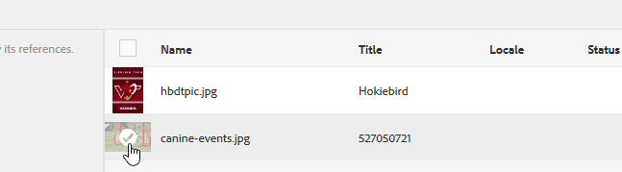
Then you can add your Title and Alternate Title. Then click “Done” then the red bar will go away
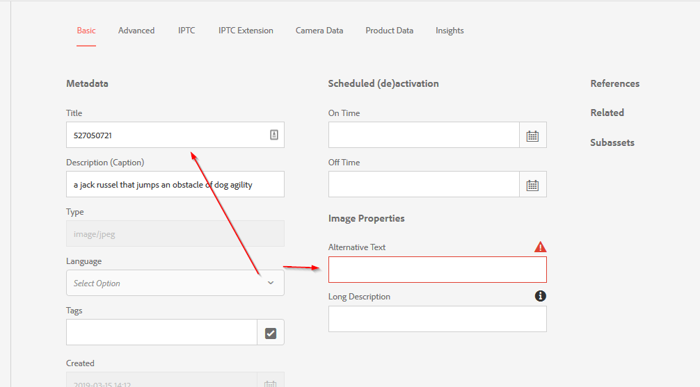
Once the Asset has been uploaded you can go back to your My Sites and navigate to the page you would like to add your asset. Images will either go into the Gallery or Image container. Files you will need to create a hyperlink to.
So, you would open up the Image holder with the Configuration Wrench and select the Assets Container and you will drag and drop the picture into the image container and then click the check mark.

Page Templates:

Tech has given us Templates that make things easier to get started. As you see below they are General, Article Page, Biography Page, Redirect Page, Research Page, Search Page, Access Page, and a Generic Home Page. The most popular pages you are going to be using is General, Biography Page, and the Redirect Page.

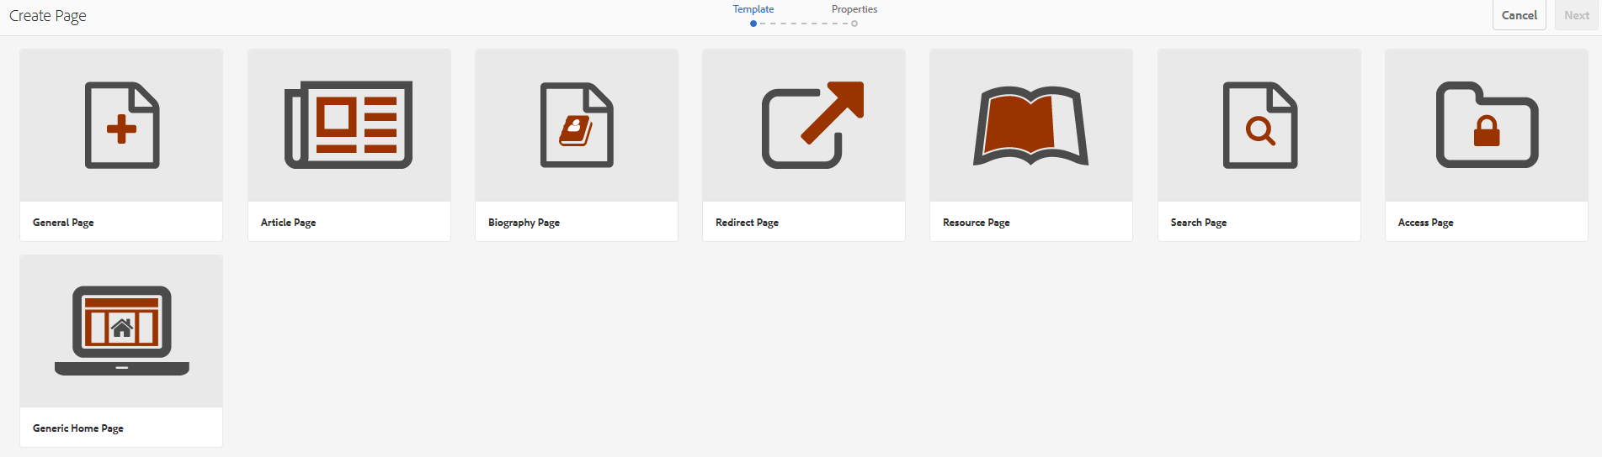

Components:
- Analytics - https://ensemble.cms.vt.edu/docs/components/vtanalytics.html
- Container - https://ensemble.cms.vt.edu/docs/components/vtcontainer.html
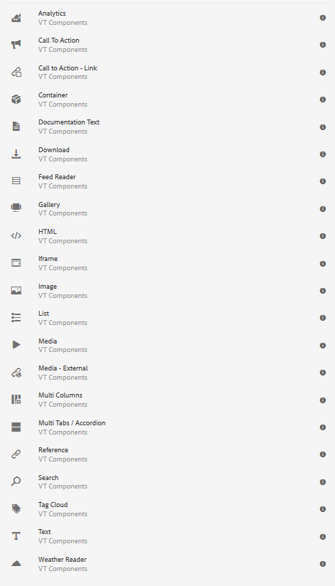
- Download - https://ensemble.cms.vt.edu/docs/components/download.html
- Documentation Text
- RSS Feeder - https://ensemble.cms.vt.edu/docs/components/feedreader.html
- Gallery - https://ensemble.cms.vt.edu/docs/components/gallery.html
- HTML - https://ensemble.cms.vt.edu/docs/components/rawhtml.html+
- iFrame - https://ensemble.cms.vt.edu/docs/components/external-iframe.html
- Image - https://ensemble.cms.vt.edu/docs/components/adaptiveimage.html
- List - https://ensemble.cms.vt.edu/docs/components/list.html
- Media - https://ensemble.cms.vt.edu/docs/components/media.html
- Media-External - https://ensemble.cms.vt.edu/docs/components/mediaexternal.html
- Multi-Column - https://ensemble.cms.vt.edu/docs/components/vtmulticolumn.html
- Reference - https://ensemble.cms.vt.edu/docs/components/reference.html
- Search - https://ensemble.cms.vt.edu/docs/components/search.html
- Text - https://ensemble.cms.vt.edu/docs/components/text.html
- Call to Action
- Call to Action Link

Add an Image to your page:

Go to the Drag Components box on your screen, double click on the box and you will get a menu. Select Image from the list.
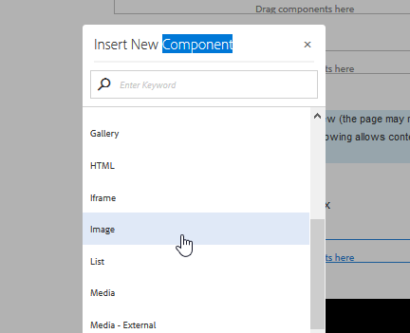
Click on the image box and select the configure wrench.
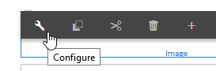
Then select the component option in the top left, then when that is open select the assets option second down on the left-hand side.
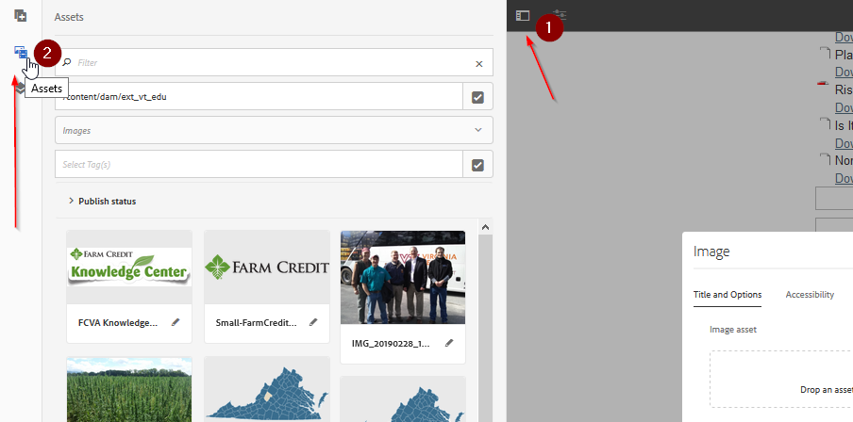
Find the picture you are looking for and drag it to the picture holder in the image component.
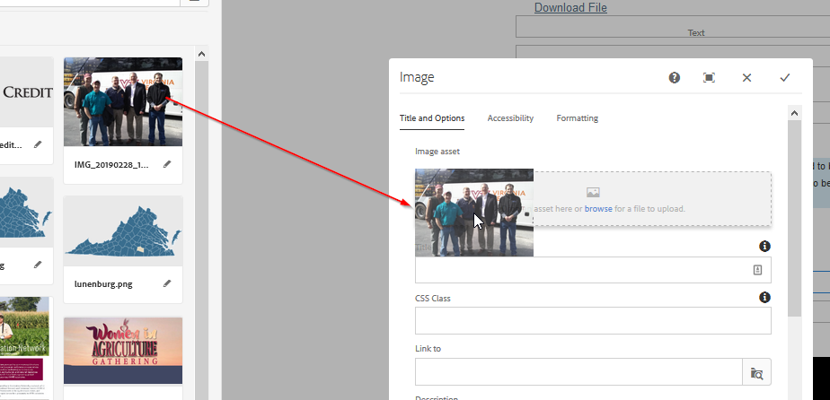
After moving the picture into the image holder make sure you fill in the Title, Alternate Title and the Image size and alignment.
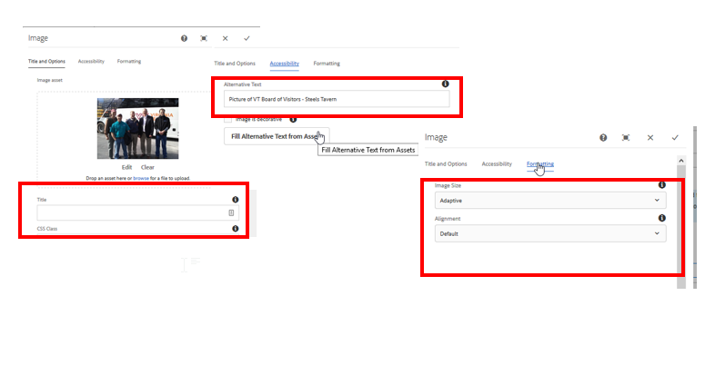

Link a Document onto the page:

Start by adding a text box component onto the page.

Add a heading for the file to be linked to, then highlight the title and click the hyperlink button
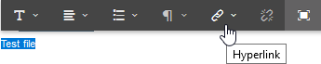
If you are linking to an external page you can post the URL into the path field if not click the checkmark
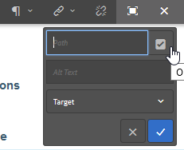
When you click the check mark you are going to path to the Assets folder, find your county location, choose your files folder and select your file. Then click the checkmark on the file and hit select
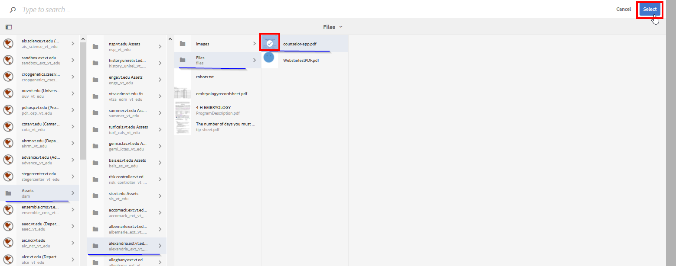
Remember to change your target to be a New Tab, that way they always stay on your website.
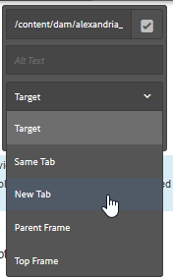
Once you are done click the checkmark to close the text component and it will be saved.
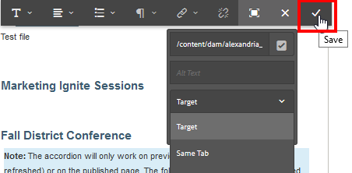

Publish:
Publish has changed. You can either Quick Publish or Manage Publication.

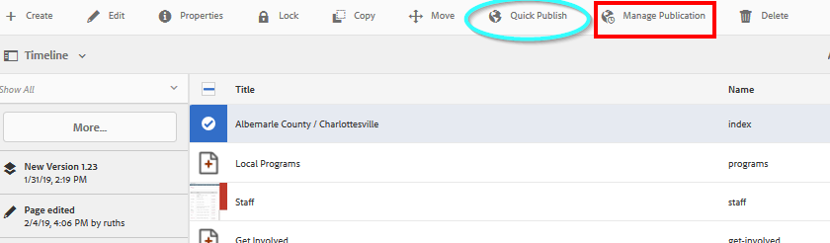
If you click Quick Publish it will publish your page without any other requirements. If you click Mange Publication you will be given the following screen.
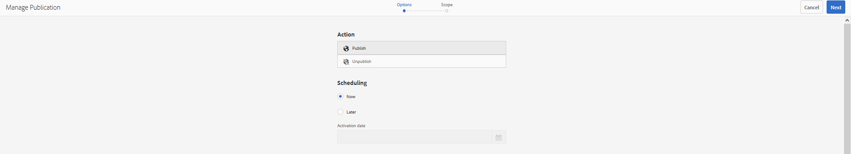
With Manage Publication it gives you the rights to Publish or Unpublish your page. You can select a time either Now or Later. If you choose later it will need to choose a date and time like you see below.
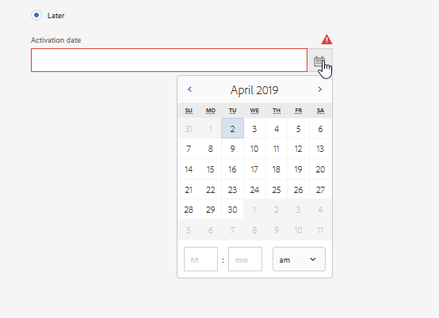
Then select Next in the top right-hand corner to publish/unpublish your content by your standards.

Breadcrumbs:

Breadcrumbs have also changed locations; the new location is located in the center of your screen like you see below.
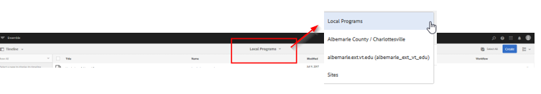

To view the different steps, click the down arrow. The newest steps at the top.

Social Media:

To be able to enter your social media links for your sidebar you will need to enter your “EN” Page.
Click the icon beside the name and click edit
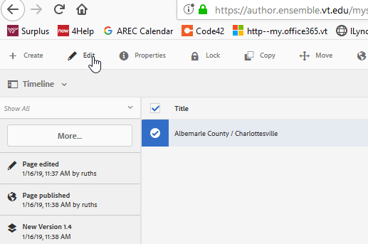
Scroll Down to your social media section, below your map
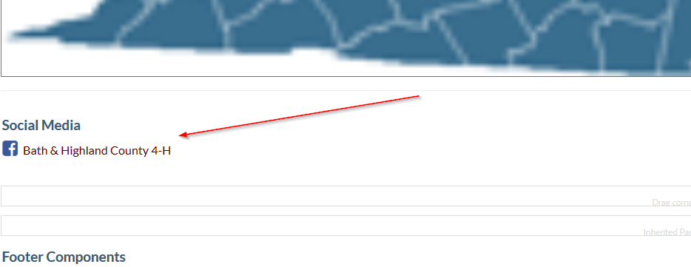
Social Media has changed, to be able to do this feature you will need to add an HTML component to the EN Page instead of a text box. Below you will see the code that will go into that. To be able to edit the HTML component you will need to click the wrench.
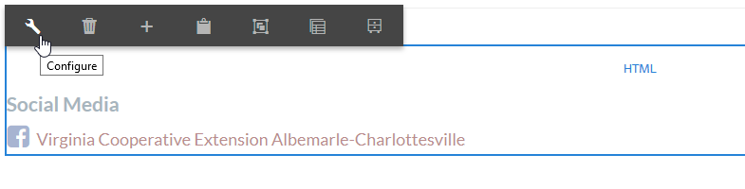
Once you do that you will see the code portion that goes into the website and the tags.
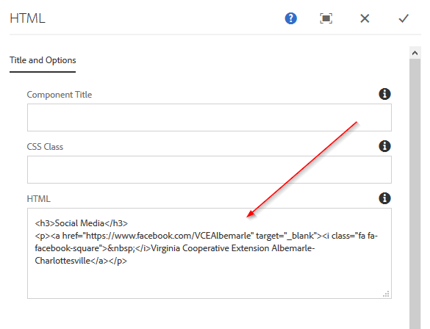

Once you are done click the checkmark in the right-hand corner of the dialog box. Below is code behind the social media links and icons:
When you are entering the connection information there are three important areas for you to complete to make sure it works every time.
- Web Address
- Social Media Icon Code
- Website Tag
Below you will find the information for the social media icon code that is available for you to use.
The icons all follow the format of:

<i class="fa fa-whatever-icon">&nbsp;</i>

The preferred social media icon codes we use are the following:

Facebook: <i class="fa fa-facebook-square">&nbsp;</i>
Twitter: <i class="fa fa-twitter-square">&nbsp;</i>
Flickr: <i class="fa fa-flickr">&nbsp;</i>
Google Plus: <i class="fa fa-google-plus-square">&nbsp;</i>
Instagram: <i class="fa fa-instagram">&nbsp;</i>
LinkedIn: <i class="fa fa-linkedin-square">&nbsp;</i>
Pinterest: <i class="fa fa-pinterest-square">&nbsp;</i>
Reddit: <i class="fa fa-reddit-square">&nbsp;</i>
Tumblr: <i class="fa fa-tumblr-square">&nbsp;</i>
Vimeo: <i class="fa fa-vimeo-square">&nbsp;</i>
Vine: <i class="fa fa-vine">&nbsp;</i>
Youtube: <i class="fa fa-youtube-square">&nbsp;</i>
Wikipedia: <i class="fa fa-wikipedia-w">&nbsp;</i>
Wordpress: <i class="fa fa-wordpress">&nbsp;</i>

Example code for Social Media text area:
<h3>Social Media</h3>
<p><a href="https://www.facebook.com/BathHighlandCounty4H/" target="_blank"><i class="fa fa-facebook-square">&nbsp;</i>(Name of Site)</a></p>

The code for the most common social media platforms will be listed again under the section to create social media icons.

When you are finished press the expand button again and click the check mark. Publish the “EN” and the “Index” Page for this change to take place.

