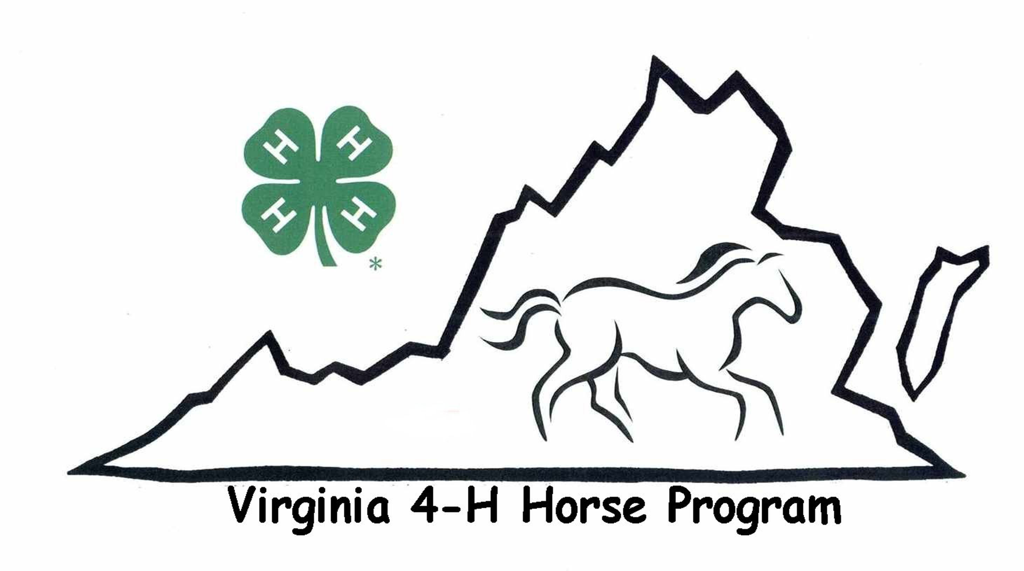
Virginia 4-H State Championship Horse and Pony Show Silent Auction
September 10 - 13, 2020
Virginia Horse Center, Lexington
Item Donation Form
This form must accompany the donated item!

Business or Individual’s Name:

Contact Person if Business:

Title:

Address:

City, State, Zip:

Home phone: Work phone:

E-mail address:

Item:

Detailed description of item:

Fair market value: $ (Fair market value must be assigned by the donor)

If this is a gift certificate, is it included with this form? yes no

Minimum bid required? yes no If yes, amount: $__

Auction item delivery or pick up? We would like all items by Wednesday, Sept 9 (earlier if possible).
I will deliver the item to the State 4-H Horse Show (All items must be clean before donating)
I need the item to be picked up at my business
(Call Rose at 540-877-4935 or e-mail horsemomrose@yahoo.com to arrange for delivery, pick-up, and/or storage)

PLEASE FILL OUT THIS FORM FOR EACH ITEM DONATED! WE APPRECIATE IT!

Thank you so much for your support of the Virginia State 4-H Horse Program!!



If you are a person with a disability and desire any assistive devices, services or other accommodations to participate in this activity, please contact Frederick County Extension Office at (540-665-5699) during business hours of 9a.m. and 4p.m. to discuss accommodations 5 days prior to the event. *TDD number is (800) 828-1120.Extension is a joint program of Virginia Tech, Virginia State University, the U.S. Department of Agriculture, and state and local governments.

