B | I | N | G | O
Go for a 30  minute ride or drive.  (Don’t for get to wear your helmet) | Choose/print  your 4-H horse project book* | Clean riding boots | Clean isle/walkways in and around barn. | Check fence lines and make repairs as needed.
Pick (Clean)  a stall | Wash your saddle pad and girth/cinch | Give your horse a bath | Feed and water horse | Give horse scratches and pats.
Wash feed and water buckets | Pick all 4 hooves | 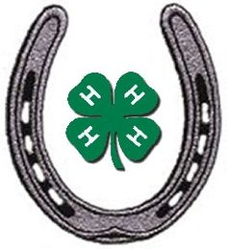  enrolled in 4honline.com | Check stall for hazards and fix any problems. | Clean and shine saddle  (Check for damage too)
Braid horse’s mane/tail | Curry horse’s body | Clean bit | Take a selfie with your horse  #VA4HHorse | Spend 20 minutes working in project book
Clean and organize tack room | Do 15 minutes of ground work | Go on a trail ride  (Don’t for get to wear your helmet) | Clean and oil bridle  (or headstall) | Strip stall and add fresh bedding

- Call or e-mail your extension agent/horse leader to discuss goals and get help selecting record book.
Kelly Rose at 276-926-4605 on Thursdays 9 am to 3 pm or e-mail rosek@vt.edu
Cell number: 276-207-1864 I’m also available to video conference by appointment via Zoom.

