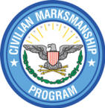
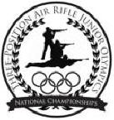
State Three-Position Air Rifle Junior Olympics
Team Registration Card

Name of School or Club |  | Team Contact
Daytime phone |  | Email
Mailing Address |  | Classes  Sporter OR Precision  Scholastic OR Club
Please provide the name and competitor number of each person who will represent your school or club.
Last/Family Name | First Name, MI | *CMP Comp #* | Position

Instructor/Coach

(to be listed as head coach on results)
 |  |  | Team Member
 |  |  | Team Member
 |  |  | Team Member
 |  |  | Team Member

The four members of this team must be selected prior to the event. Should the team qualify for Nationals, the members may be changed.

Look up CMP Numbers at: http://odcmp.com/Competitions/CreateACMPNumber.pdf

This form must be submitted by the match director to CMP with the match results.

