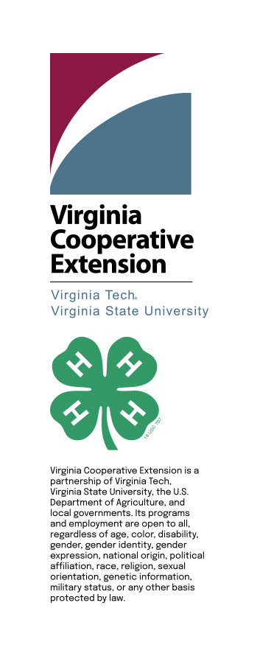

If you are a person with a disability and desire any assistive devices, services or other accommodations to participate in these activities, please contact the State 4-H office at (540) 553-5854 (TDD 800-828-1120) during the business hours of 8:00 AM to 4:30 PM by the deadline.

2025
Calendar
for
Virginia
Shooting
Education

2025 Virginia 4-H Shooting Education Calendar of Events
As of January 11, 2025

date | Event
Jan 3 - 5 | Virginia 4-H Shooting Sports Teen Ambassador Training. Skelton 4-H Center. Contact Robert Tillotson ricochetrobert56@gmail.com
Jan 4 & 5 | Virginia 4-H Shooting Education Council Meeting. Skelton 4-H Center. Contact Lynn Wheeless lynnwheeless@gmail.com
Jan 25 | Friends of NRA State Fund Committee Meeting. Bass Pro Shops, Ashland. Contact Brandon Spence, NRA Field Representative. bspence@nrahq.org
Feb 17 - 21 | 2025 National 4-H Shooting Sports Quiz Bowl. Online quiz includes shooting discipline questions in addition to general 4-H and STEM related questions. For registration links and study guides, go to https://4-hshootingsports.org/2025-quiz-bowl-information/
Feb 22, 2025 | 4-H Instructor Re-Certification for current Level I Instructors in Archery, Muzzleloading, Pistol, Rifle and Shotgun. Holiday Lake 4-H Center. Coordinator re-certification offered online only. Contact Lynn Wheeless for additional details.
Mar 14 - 16 | Virginia 4-H Spring Air. Competitive events in Air Pistol, Air Rifle, Archery, BB Gun, Presentations and Public Speaking. Virginia 4-H BB Gun Championship. Top three BB teams qualify to represent Virginia  4-H at the Daisy National Championship Match in Rogers, Arkansas. Skelton 4-H Center. Contact Robert Tillotson.
Apr 5 & 6 | Spring 4-H Instructor Certification. Holiday Lake 4-H Center. Level I certification in archery, coordinator, hunting/outdoor skills, muzzleloading, pistol, rifle or shotgun. Contact Lynn Wheeless.
April 20 | Easter
May 2 – 4 | Hunter Education Challenge. Holiday Lake 4-H Center. Competitive events in sporting clays, rifle silhouettes, 3-D archery, outdoor skills and hunter responsibility exam. Sponsored by the Virginia Department of Wildlife Resources (DWR).
May 5 – 8 | Spring National 4-H Shooting Sports Workshop. Vines/Arkansas 4-H Center, Little Rock, Arkansas. National workshop to certify Level II instructors to serve on state training teams. Must be Level I certified at the state level to apply. Contact Lynn Wheeless.
May 14 - 16 | Summer Camp Staff Only 4-H Instructor Certification. Airfield 4-H Center. Training in archery or rifle.
May 17 & 18 | Workday and Virginia 4-H Shooting Education Council Meeting. Holiday Lake 4-H Center. Contact Lynn Wheeless.
Jun 1 | State AIM Shoot. Trap only. Winchester Gun Club. Sponsored by the Virginia Trapshooting Association. Contact BD Wood aimvirginia@yahoo.com
Jun 21 | Southeast District 4-H Shoot. Airfield 4-H Center. Competitive events in archery, air pistol, air rifle, BB gun, smallbore pistol silhouette, smallbore rifle and shotgun. Contact Lynn Wheeless.
Jun 22 - 27 | 4-H Shooting Sports National Championships. Grand Island, Nebraska. Matches in air pistol, air rifle, archery compound, archery recurve, hunting and outdoor skills, muzzleloading, shotgun, smallbore pistol or smallbore rifle.
Jun 29 – Jul 2 | Daisy National BB Gun Championship Match. Rogers, Arkansas. Top three BB Gun teams from Spring Air qualify to represent Virginia 4-H. Go to www.dnbbgcm.com/ for additional information.
Jul 10 – 13 | Youth Education Summit (YES). Richmond. A leadership and scholarship program for rising freshman, sophomores and juniors. Rising seniors also invited but ineligible to attend the National YES program in Washington DC. Students explore Virginia government and the U.S. Constitution with emphasis on the Bill of Rights. Students are encouraged to participate in the democratic process in their communities. Sponsored by the Virginia Friends of NRA Committee. Contact Jaye Pearce jpandjon@aol.com
Jul 12 | Central District 4-H Shoot. Holiday Lake 4-H Center. Competitive events in archery, air pistol, air rifle, BB gun, smallbore rifle, smallbore pistol silhouette, and shotgun. Contact Sarah Edens soggybottomcows@yahoo.com
Jul 27 - 31 | VA 4-H/NRA Shooting Education Camp. Holiday Lake 4-H Center. Camp for youth ages 12 to 16 in archery, muzzleloading, pistol, shotgun, smallbore rifle, or natural resources/environmental education (NREE). Register online at: https://www.holidaylake4h.com/nra-4-h-shooting-education-camp.html
Aug 9 | Northern District 4-H Shoot. Cedar Mountain Youths Range, Culpeper. Competitive events in archery, air pistol, air rifle, BB gun, smallbore rifle, muzzleloader and shotgun. Contact Mark Willey willeym@gmail.com
Sept 5 | Virginia 4-H Shooting Education Council Meeting. Holiday Lake 4-H Center. Contact Lynn Wheeless.
Sept 6 & 7 | State 4-H Shoot. Holiday Lake 4-H Center. Competitive events in air pistol, air rifle, archery, BB Gun, hunting and outdoor skills, muzzleloading, shotgun, smallbore pistol and smallbore rifle. Contact Lynn Wheeless.
Sept 20 | RL Harris Jr Memorial 4-H Shotgun Championship. Brushy Mountain Club. Competitive events in Trap, Skeet and Sporting Clays. The 2025 Shotgun Championship is the qualifying event to represent Virginia at the 2026 4-H Shooting Sports National Championships in Nebraska. Contact David Maddox firearmfixer@gmail.com
Oct 11 & 12 | Fall 4-H Instructor Certification (or inclement weather date for the State 4-H Shoot). Holiday Lake 4-H Center. Level I certification in archery, hunting/outdoor skills, muzzleloading, pistol, rifle and shotgun. Contact Lynn Wheeless.
Dates? | Fall National 4-H Shooting Sports Workshop. Location? State? National workshop to certify Level II instructors to serve on state training teams. Must be Level I 4-H certified at the state level to apply. Contact Lynn Wheeless.
Nov 1 | 4-H Instructor Re-Certification for current Level I Instructors in Archery, Muzzleloading, Pistol, Rifle and Shotgun. Holiday Lake 4-H Center. Contact Lynn Wheeless.

For additional information contact:

Lynn Wheeless, Coordinator, Virginia 4-H Shooting Education Program
lynnwheeless@gmail.com (757) 778-1078

If you are a person with a disability and desire assistance or accommodation, please notify
Lynn Wheeless (757-778-1078) during business hours of 8:30 a.m. and 5:00 p.m.
*TDD number is (800) 828-1120.

